Student Assessment Submission and Declaration
When submitting evidence for assessment, each student must sign a declaration confirming that the work is their own.
Student name:ADEL SHURAB  21023153 |  | Assessor name:  Dr. Sarah Shukri
Issue date (1St Submission):  23/11/2022 | Submission date (1St Submission):  20/1/2023 |  | Submitted on:
In case of resubmission
Issue date (1St Submission):  24/1/2023 | Submission date (1St Submission):  27/1/2023 |  | Submitted on:
Programme: HND in Computing - Intelligent Systems
Assignment number and title:
1- Machine Learning's Terminologies and Algorithms

Your answer must be here:

TASK 1:
Q1: PRESENT DIFFIRENT TYPES OF LEARNING:
1: Supervised learning, is a subcategory of machine learning and artificial intelligence also known as supervised machine learning. It is defined by accurately predicting outcomes. When input data is fed into the model or it uses labeled datasets to train algorithms that classify the data, it adjusts its weights until the model is appropriately fitted. Supervised learning helps organizations solve a variety of large-scale real-world problems that occur as part of the validation process. Cross health, such as categorizing spam in a folder separate from your inbox.
The work mechanism of Supervised Learning involves training a model on labeled data. The labeled data is used to train the model to recognize patterns in the data, and then the model is tested on unseen data to predict the output. This process of training and testing is repeated until the model is able to accurately predict the output of unseen data
example :Support Vector Machines (SVM): A support vector machine is a supervised learning model, typically leveraged in classification problems and used for data classification and regression. However, where a hyperplane is created is where the distance between two classes of data points is maximum. It separates classes of data points, this hyperlevel is known as a decision boundary.(1)

2:Unsupervised learning uses aggregates of data without the need for human intervention. Its ability to detect similarities and differences in information makes it the perfect solution for exploratory data analysis, or machine learning algorithms for analyzing and aggregating unlabeled data sets. These algorithms detect hidden patterns, cross-selling strategies, customer segmentation, and image recognition
The work mechanism of Unsupervised Learning involves training a model on an unlabeled dataset. The model is then used to identify patterns in the data, and those patterns are used to create clusters or detect anomalies in the data
example : where K specifies the number of clusters depending on the distance from each group's centroid, is a typical illustration of an exclusive clustering approach where data points are assigned into K groups. The data points that fall into the same category are those that are closest to a certain centroid. Smaller K values indicate bigger groupings and less granularity, while greater K values indicate smaller groupings and higher granularity. Market segmentation, document clustering, image segmentation, and image compression all frequently use K-means clustering. .(2)
3:Semi-supervised learning is the type of machine learning that uses a combination of a small amount of labeled data and a large amount of unlabeled data to train models. This approach to machine learning is a combination of supervised machine learning, which uses labeled training data, and unsupervised learning, which uses unlabeled training data.
The work mechanism of Semi-Supervised Learning involves training a model on both labeled and unlabeled data. The labeled data is used to train the model to recognize patterns in the data, and then the model is tested on the unlabeled data to make predictions. This process of training and testing is repeated until the model is able to accurately predict the output of the unlabeled data
how semi supervised work :Imagine that you have collected a large set of unlabeled data that you want to train a model on. Manually labeling all this information would likely cost you a fortune, in addition to spending months to complete the annotations. This is when the semi-supervised machine learning method comes to the rescue.
The working principle is very simple. Instead of adding tags to the entire dataset, you can browse to just a small part of the data, manually label it, and use it to train a model, which is then applied to the perimeter of the unlabeled data.(3)
example :Speech recognition:Because labeling audio requires a lot of time and resources, semi-supervised learning can be utilized to overcome these obstacles and deliver superior results. Facebook (now Meta) has successfully enhanced its voice recognition models using semi-supervised learning, namely the self-training method. They began with the base model, which was developed using 100 hours of audio data annotated by humans. The performance of the models was then improved via self-training and the addition of 500 hours of unlabeled voice data. In terms of the outcomes, there was a considerable improvement as the word error rate (WER) dropped by 33.9 percent.(4)
4:Reinforcement learning is a machine learning training method based on rewarding desirable behaviors and/or punishing unwanted behaviors. taking action and learning through trial and error, in general, the reinforcement learning agent is able to perceive and interpret its environment.(5)
The work mechanism of Reinforcement Learning involves training an agent to take actions in an environment in order to maximize a certain reward. The agent is trained by trial and error, and is rewarded for taking the correct actions and punished for taking the wrong actions. Over time, the agent learns to take the correct actions in order to maximize the reward
Example : Self-drive car
how it work :A reinforcement learning problem involves an operator exploring an unknown environment to achieve a goal. RL is based on the premise that all goals can be described by maximizing the expected cumulative reward. The formal framework of RL borrows from the problem of optimal control in Markov decision processes (MDP). An agent must learn to sense the state of the environment and perturb it using its actions to obtain maximum reward.(6)
Q2:MACHINE LEARNING
what is machine learning:
Machine learning (ML) is a type of artificial intelligence (AI) that allows software applications to become more accurate in predicting outcomes without being explicitly programmed to do so. Other common uses include fraud detection, spam filtering, malware threat detection, business process automation (BPA), and predictive maintenance. Machine learning algorithms use historical data as input to predict new output values.Recommendation engines are a common use case for machine learning.
Why is machine learning important?
Machine learning is important because it gives enterprises a view of trends in customer behavior and business operational patterns, as well as supports the development of new products. Many of today's leading companies, such as Facebook, Google and Uber, make machine learning a central part of their operations. Machine learning has become a significant competitive differentiator for many companies.
Machine learning can be the key to unlocking the value of corporate and customer data and making decisions that keep a company ahead of the competition, because data is the lifeblood of all business. Data-driven decisions are increasingly making the difference between keeping up with the competition or falling behind.(7)
Q3:the differeces between traditional programming and machine learning :
traditional programming :Conventional programming is a manual process - in the sense that there is a programmer inputting the code but without anyone programming the logic, the programmer has to manually formulate or code the rules.
For example, we can write a conventional computer program to recognize an activity (walking, running, or cycling) from a person's speed (the data) and define an activity (walking, running, cycling) based on the speed (the rules). However, the problem with this approach is that different people walk, run, and cycle at different speeds depending on their age, environment, health, etc.
input + program = output
machine learning : Unlike traditional programming, machine learning is an automated process. It can increase the value of embedded analytics in many areas, including natural language interfaces, data preparation, automatic detection of recommendations and anomalies, and discovery of causality and significance. All of these features help accelerate the reduction of decision bias and user insights.
input+output=program
For example, if you take transaction and customer demographic data as input data and use historical customer inflation rates as output data, the algorithm will craft a program that can predict whether or not a customer will flounder. This program is called the predictive model.
input(Demographics + Transantions)+output(Churned orNot)=program(ChurnModel)(8)
Q4: types of data variables (9)
Nominal:A nominal variable is one that describes a name, label or category without natural order. Sex and type of dwelling are examples of nominal variables
Ordinal:An ordinal variable is a variable whose values are defined by an order relation between the different categories
Binary: A binary number system, binary system, or binary number system is a base-2 number system used to represent numerical values ​​using two symbols, usually 0 and 1. Any two symbols or states such as 0 and 1, true/false, or on/off can also be used.
Integer:An integer is one that can be written without using fractions or decimal places, and the set of integers, which is a subset of the set of real numbers, consists of the natural numbers, zero, and the negative numbers corresponding to the natural numbers.
Interval-scaled:a quantitative measurement scale where there is order, the difference between the two variables is meaningful and equal, and the presence of zero is arbitrary
ratio-scaled: a quantitative scale where there is a true zero and equal intervals between neighboring points
here example from dataset:
Nominal:
Type of breast cancer (e.g. invasive ductal carcinoma, invasive lobular carcinoma)
Ordinal:
Stage of breast cancer (e.g. stage 1, stage 2, stage 3)
Binary:
Presence of breast cancer (e.g. 1 for positive and 0 for negative)
Integer:
Size of tumor in millimeters
Number of lymph nodes involved
Interval-scaled:
Age of patient
Duration of symptoms
Ratio-scaled:
Size of tumor in millimeters
Number of lymph nodes involved

Q5 :machine learning algorithms
classification algorithm : a supervised learning technique that is used to select the class of new observations based on the training data. The selected observations then classifies the new observation into a number of categories or groups or in classification, the program learns from the data set. Like, yes or no, 0 or 1, spam or not spam, cat or dog, etc. Categories can be named as targets/labels or categories.
Regression : another widely important tool for statistical and machine learning. The main objective of the tasks is based on the responses that appear, showing immediate data or regression. The output will depend on what the model has learned in the training phase. Essentially, regression models use input data (dependent variables) and output variables) a specific association between the corresponding input and output or their corresponding numerical output values ​​(the dependent variables).
Clustering or cluster analysis : a method of grouping entities based on similarities. It is defined as an unsupervised learning problem that aims to generate training data with a given set of inputs but without any target values. It is the process of finding similar structures in a set of unlabeled data to make it more understandable and manipulative
Optimization: are used to choose which measure to maximize or minimize in order to identify the best solution to a problem. Numerous issues can be resolved using optimization algorithms, such as figuring out the best way to distribute resources or finding the shortest route between two sites.
In general machine learning is useful for many fields to analyzing big data and used in finance , healthcare, marketing , transportation ,and more
K-nearest neighbors (KNN) is a supervised learning algorithm that can be used for classification and regression problems. In the case of a breast cancer dataset, KNN can be used for classification by determining whether a new sample is benign or malignant based on the characteristics of the samples in the dataset
For instance, let's say we have a breast cancer dataset with 30 samples, where 15 samples are labeled as benign and the other 15 samples are labeled as malignant. We can use the KNN algorithm with k=5 to classify new samples based on their features. When a new sample is presented to the model, the algorithm will find the 5 closest samples in the dataset (based on their feature values) and will classify the new sample as benign if most of the 5 closest samples are benign, and as malignant if most of the 5 closest samples are malignant.

It's important to note that breast cancer diagnosis is a complex task and needs expert's attention and this example is just a simple illustration of how KNN works, and not a substitute for professional medical advice.
Q6: Intelligent machine in medical care:
How AI used healthcare today?
Radiology - Artificial intelligence helps analyze x-ray images in a correct way without any human errors, detects cancerous tumors faster, and clarifies x-rays more clearly.
Drug discovery - AI is developed by providing it with a database with information about drugs to help produce drugs that help treat viruses and serious diseases and accelerate the process of bringing new drugs to market in response to the threats of deadly diseases.
Identifying patient risks – From analyzing data to a patient's record, AI can provide real-time support to clinicians to help identify patients at risk by highlighting patients who have an increased chance of returning to hospital within 30 days of discharge. Based on data in a patient's electronic health record, AI can identify all risks to a patient Other recent work has shown the ability to predict cardiovascular disease risk based on a static image of a patient's retina.
Q7: Machine learning algorithm:
1-KNN:This algorithm can be applied to classification and regression problems. Apparently, in the data science industry, it is widely used to solve classification problems. It is a simple algorithm that stores all available cases and ranks any new cases by majority vote of its neighbors. The status is then assigned to the class with which you have the most in common. The distance function makes this measurement.
KNN can be easily understood by comparing it to real life. For example, if you want information about a person, it makes sense to talk to his or her friends and colleagues!
Things to consider before selecting K Nearest Neighbours Algorithm:
KNN is computationally expensive
Variables should be normalized, or else higher range variables can bias the algorithm
Data still needs to be pre-processed.
You might train the algorithm on a dataset of cancer cases including parameters like tumor size, the presence of specific proteins, and the result in order to apply KNN for cancer identification (i.e. whether the patient has cancer or not). Based on the patterns and characteristics it discovered from the training data, the algorithm would learn to categorize new instances as either positive or negative for cancer.

2- Naive Bayes classifier :assumes that the presence of a particular feature in a class is unrelated to the presence of any other feature.
Even if these features are related to each other, a Naive Bayes classifier would consider all of these properties independently when calculating the probability of a particular outcome.
A Naive Bayesian model is easy to build and useful for massive datasets. It's simple and is known to outperform even highly sophisticated classification methods.
You may train the algorithm on a dataset of cancer cases with variables like tumor size, the presence of specific proteins, and the prognosis in order to employ Naive Bayes for cancer identification (i.e. whether the patient has cancer or not). Based on the probability of the presence or absence of the various features, the algorithm would learn to predict the chance of a new case being positive or negative for cancer.
3-SVM algorithm : a method of a classification algorithm in which you plot raw data as points in an n-dimensional space (where n is the number of features you have). The value of each feature is then tied to a particular coordinate, making it easy to classify the data. Lines called classifiers can be used to split the data and plot them on a graph
You may train the SVM algorithm on a dataset of cancer cases with parameters like tumor size, the presence of specific proteins, and the prognosis in order to utilize it to detect cancer (i.e. whether the patient has cancer or not). On the basis of the hyperplane it learned from the training data, the algorithm would learn to identify new instances as either positive or negative for cancer.
4-ANN:The structure and operation of the human brain served as the inspiration for the machine learning algorithm known as ANN. You may train the ANN algorithm on a dataset of cancer cases with parameters like tumor size, the presence of specific proteins, and the prognosis in order to utilize it to detect cancer (i.e. whether the patient has cancer or not). On the basis of the patterns and connections it discovered from the training data, the algorithm would learn to categorize fresh instances as either positive or negative for cancer.
With general, by learning from the data and making predictions or judgments based on this learning, these machine learning algorithms can be utilized to aid in the challenge of cancer diagnosis. Every method has advantages and disadvantages, and the optimal option will rely on the particulars of the data and the application's requirements.(10)
TASK 2 :
Q8-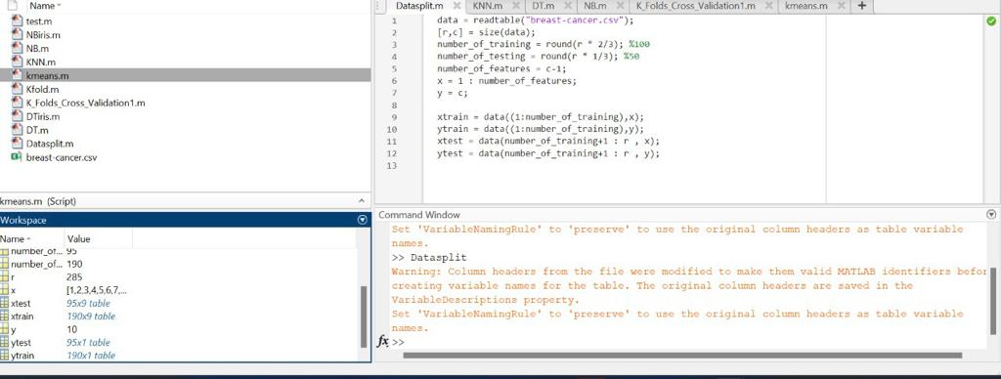
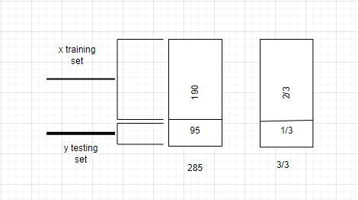
Given that this table contains a sample of the data, we divide the data into two parts: training and testing. Therefore, from 1 to 190, all of them pertain to training (Xtrain) and refer to (Ytrain) in the class, while the other is for testing (Xtest) and refers to in the class 9n (Ytest). Furthermore, one class refers to Y and the other to X. (variables)
Q9:
Algorithm | Dataset | Accuracy
KNN | iris | 96%
Naive bayes | iris | 96%
Decision Tree | iris | 98%
Q10:
These algorithms are very effective as they have been applied in many areas of health and are effective with breast cancer and have also been used by many,for example including the Mia algorithm for breast examination in the English project, Kheiron Medical Technologies has proven itself in addition to a second opinion. The first results of more than 40 mammograms showed that if Mia had been used as a second radiographer, the overall double read frequency rate (percentage of women called for further examination) would be 4-5%, and the cancer detection rate would be 8,4, 1 person per thousand patients.(11)
Advantages | Disadvantages
Early detection of cancer so that a person can receive treatment before it is too late | Giving a false result by predicting cancer to an uninfected person
Reducing time by facilitating the medical process | Not correcting the error when it occurs
Less chance of misdiagnosis , Where he can find imperceptible malignant tumors

Q11-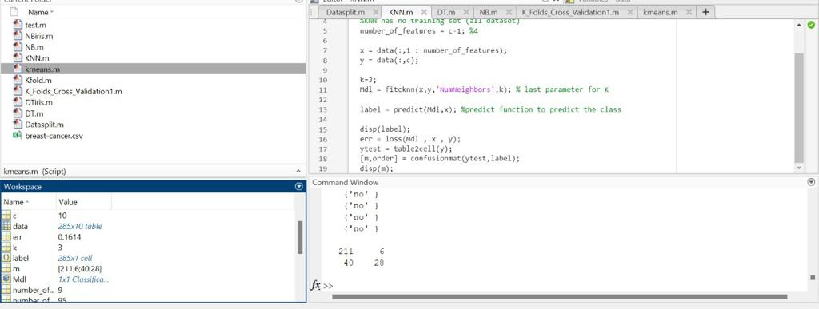
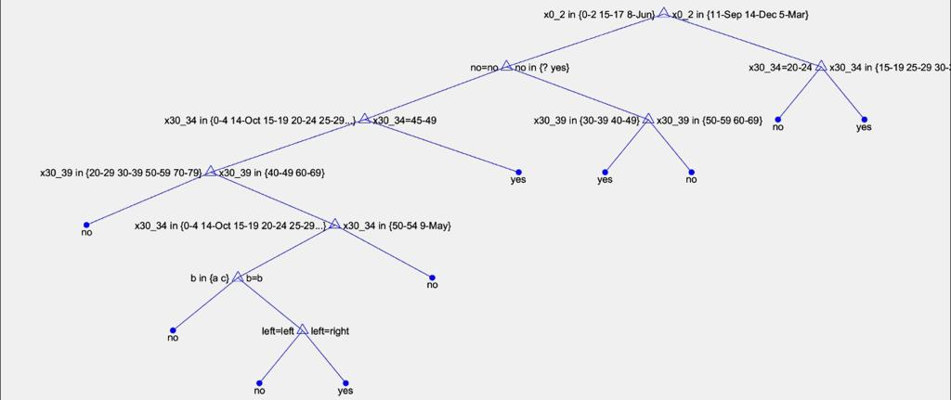
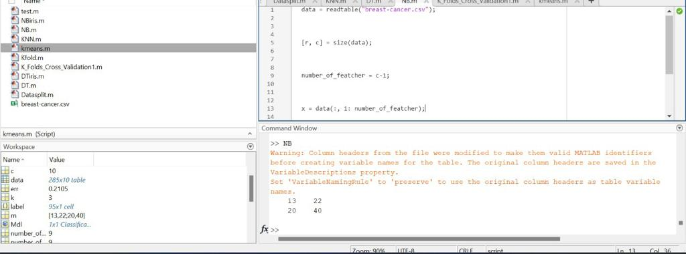
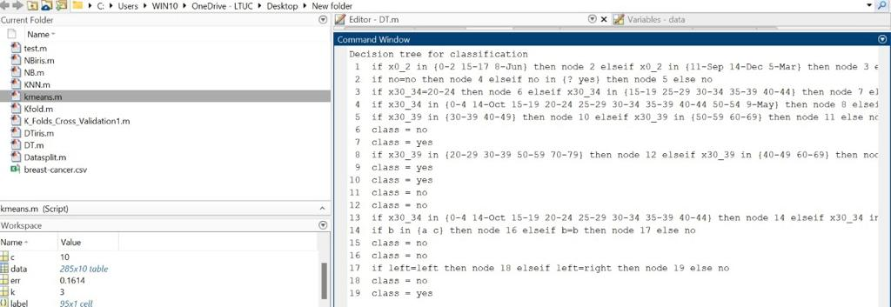

Q12-the best result in DT because it had a best accuracy.
 | Predicted
actual | 13 | 22
 | 20 | 40

Q13- (underfitting or over-fiitning)
Overfitting is defined as "producing an analysis that agrees too closely or completely with a given set of data, and thus may fail to fit additional data or reliably predict future observations"
an over-model is a statistical model that has more parameters than can be justified by the data. The essence of over-allocation is to inadvertently extract some residual variance (i.e. noise) as if that variance represented the underlying model structure.(12)
As for
Underfitting: Occurs when the statistical model cannot adequately capture the underlying structure of the data. An improper form is a form in which some parameters or terms that would appear in a properly defined form are missing. Underfitting may occur, for example, when fitting a linear model to nonlinear data. This model tends to have poor predictive performance.(12)
In fact, I did not encounter any of these, as the results were perfect and reasonable, as they did not reach 100% and were not less than 60%, as shown in the previous results, and this means that the algorithm works well and correctly without any errors
Q14-table 1: CM for DT
 | Predicted
actual | 211 | 6
 | 40 | 28
Acc= 239/285=83%
Pre=211/217=97%
Recall =211/251=84%
table 2: CM for NB
 | Predicted
actual | 13 | 22
 | 20 | 40
Acc= 53/101=52%
Pre=13/35=37%
Recall =13/33=39%
Table 2: CM for KNN
 | Predicted
actual | 13 | 22
 | 20 | 40
Acc= 53/101=52%
Pre=13/35=37%
Recall =13/33=39%
Q15- assess
Algorithms helped solve this problem by early detection of the disease and by reducing detection errors and finding and discovering tumors that humans may not see and they perform predictive studies to detect the disease and this helps in disease prevention as it gives accuracy in the test and examines the stomach tissues And suggesting treatments for the disease, and also one of the positives of the algorithms is that it gives the result of the examination within second Through early detection, machine learning algorithms can help detect breast cancer at an early stage by analyzing medical imaging such as mammograms, and also by detecting vital signs. Algorithms can help find new breast Through early detection, machine learning algorithms can help detect breast cancer at an early stage by analyzing medical imaging such as mammograms, and also by detecting vital signs. Algorithms can help find new breast cancer biomarkers by analyzing large quantities. of genomic and proteomic data. Machine learning algorithms can predict the effectiveness of individual treatments for patients based on their medical history and genetic information. Algorithms can help discover new breast cancer drugs by analyzing large-scale drug screening data. False negatives/false positives in breast cancer diagnosis by analyzing patient data and improving diagnostic accuracy.
The algorithm was then used to classify new cases as either benign or malignant, allowing doctors to make more accurate and timely diagnoses. This can lead to earlier detection and treatment of breast cancer, which can improve patient outcomes.
The algorithm's capacity to process massive volumes of data and automate the detection of breast cancer can boost effectiveness and lessen the workload of medical specialists.
Additionally, the algorithm can be developed using patient-specific information, enabling a more customized diagnostic and treatment strategy.

Q16-
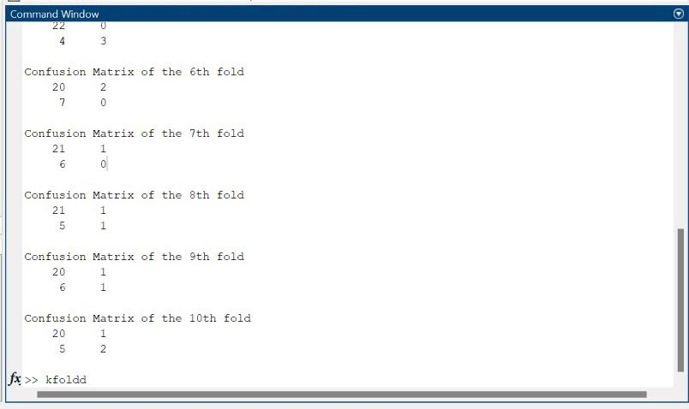
the best folds is 5 because his accuracy is 86%
Q17- Yes, it helped us to apply different types of algorithms and get a good result There are a number of algorithms that help in the medical field, as I mentioned in one of the answers about one of them, which is the Mia algorithm that specializes in examining breast cancer, and it is currently the strongest. It reads radiological images and other algorithms that have different advantages from each other, and this means that the algorithm works as required. is shown
And early detection helps us to take precautions and treatments in a way that prevents the spread of cancer, and these algorithms help in this disease and others who need early detection to avoid its damage, and this means that the company is working as required, as it asked us to create an algorithm that helps in the early detection of breast cancer by working on the algorithm Its effectiveness has been proven, as there was no overfitting or underfitting, and this is evidence of the company's work as required

REFERENCE
1-What is supervised learning? IBM. (n.d.). Retrieved January 6, 2023, from https://www.ibm.com/topics/supervised-learning
2-What is unsupervised learning? IBM. (n.d.). Retrieved January 6, 2023, from https://www.ibm.com/topics/unsupervised-learning
3-Semi-supervised learning&nbsp;. DataRobot AI Cloud. (2022, July 1). Retrieved January 6, 2023, from https://www.datarobot.com/blog/semi-supervised-learning/
4-Editor. (2022, March 18). Semi-Supervised Learning, Explained with Examples. AltexSoft. https://www.altexsoft.com/blog/semi-supervised-learning/
5-Carew, J. M. (2021, March 29). reinforcement learning. Enterprise AI. https://www.techtarget.com/searchenterpriseai/definition/reinforcement-learning
6-Verma, P., & Diamantidis, S. (2021, April 27). What is Reinforcement Learning? https://www.synopsys.com/ai/what-is-reinforcement-learning.html
7-Burns, E. (2021, March 30). machine learning. Enterprise AI. https://www.techtarget.com/searchenterpriseai/definition/machine-learning-ML
8-insightsoftware. (2022, October 11). Machine Learning vs. Traditional Programming. Insightsoftware. https://insightsoftware.com/blog/machine-learning-vs-traditional-programming/
9-4.2 Types of variables. (n.d.-b). https://www150.statcan.gc.ca/n1/edu/power-pouvoir/ch8/5214817-eng.htm
10-Tavasoli, S. (2023, January 6). Top 10 Machine Learning Algorithms For Beginners: Supervised, Unsupervised Learning and More. Simplilearn.com. https://www.simplilearn.com/10-algorithms-machine-learning-engineers-need-to-know-article
11-كيف يمكن للتعلم الآلي أن يساعد في مكافحة السرطان - طعام صحي قريب مني. (n.d.). الطعام الصحي بالقرب مني - الطعام الصحي قريب منا ومن حولنا. نحن فقط بحاجة للتعرف عليه!. https://ar.healthy-food-near-me.com/how-machine-learning-can-help-fight-cancer/
12- SuperAnnotate AI Inc. (n.d.). Overfitting and underfitting in machine learning | SuperAnnotate. https://www.superannotate.com/blog/overfitting-and-underfitting-in-machine-learning
Plagiarism
Plagiarism is a particular form of cheating. Plagiarism must be avoided at all costs and students who break the rules, however innocently, may be penalised. It is your responsibility to ensure that you understand correct referencing practices. As a university level student, you are expected to use appropriate references throughout and keep carefully detailed notes of all your sources of materials for material you have used in your work, including any material downloaded from the Internet. Please consult the relevant unit lecturer or your course tutor if you need any further advice.
Student Declaration
Student declaration
I certify that the assignment submission is entirely my own work and I fully understand the consequences of plagiarism. I understand that making a false declaration is a form of malpractice.

Student signature: Date:

